Views
Image view
Hour glass
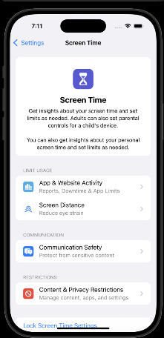
Label
Contact letter headers
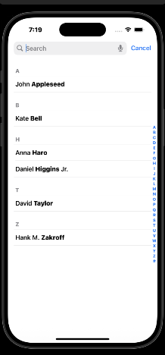

Text View
Image of text that can be highlighted or copied.

Table View
Shows scrolling list of options

Navigation Bar
Bottom of screen news app
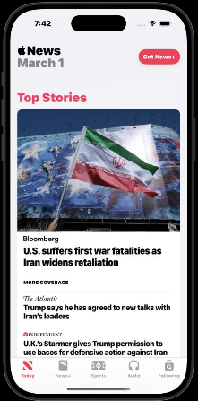

Controls

Button
Cancel button
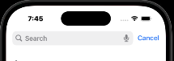

Slider
Slider at bottom for text size
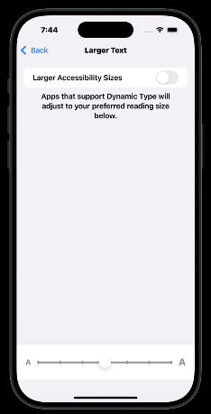
Switch
Toggle options
Text field
Enter names


